Self Reference

By: Joseph Joy

Answer: DAVID HILBERT

Assemble the 9 tiles in the correct order using the background image as an aid. You get the following.

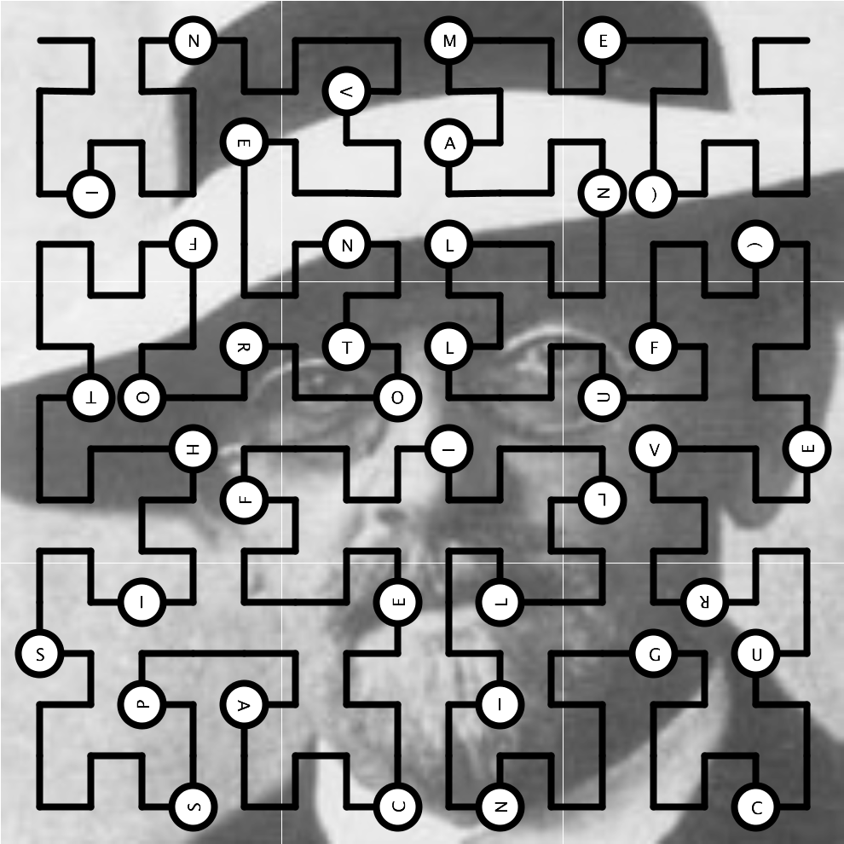

Reading the letters along the recursive space-filling curve produces “INVENTOR OF THIS SPACE FILLING CURVE (FULL NAME)”. The curve is an instance of a Hilbert curve, devised by famous mathematician David Hilbert (1862-1943), whose picture (source:Wikipedia) forms the background.